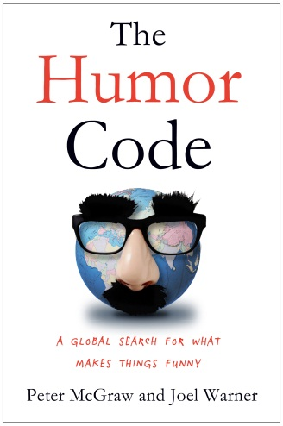
THE HUMOR CODE
A Global Search for What Makes Things Funny
-by-
Peter McGraw and Joel Warner

“By asking us to explore the reasons why we laugh, the authors force us to look inside ourselves. It’s not often you can say a book about comedy can teach us some serious lessons.
This one does—and entertains us in the process.”
—Booklist, starred review

“Engaging, wise, and of course funny, The Humor Code is a wonderful quest to discover who and what makes us laugh. Pete McGraw and Joel Warner are the best of company, and you'll be glad you took this trip with them.”
— Susan Cain, author of Quiet: The Power of Introverts in a World That Can’t Stop Talking

“The Humor Code is so good that I wish I wrote it. In fact, I’ve already started telling people I did. Luckily, Pete McGraw and Joel Warner are givers, so they won’t mind. They’ve given us a remarkable look at what makes us laugh, with the perfect blend of science, stories, satire, and sweater vests. This book has bestseller written all over it.”
— Adam Grant, Wharton professor and bestselling author of Give and Take

What do you get when a madcap scientist and a crackerjack writer cross the globe? You get not a punch line, but the extraordinary new book THE HUMOR CODE: A Global Search for What Makes Things Funny by Peter McGraw and Joel Warner (Simon & Schuster Hardcover, on sale 4/1/14, $26.00). Part road-trip comedy and part social science experiment, THE HUMOR CODE details McGraw and Warner’s epic quest to discover the secret behind humor.

Dr. Peter McGraw, founder of the Humor Research Lab (HuRL) at the University of Colorado Boulder, teamed up with award-winning journalist Joel Warner on a far-reaching search that spanned the globe, from New York to Japan, from Palestine to the Amazon. Meanwhile, the duo conducted their own experiments to test out McGraw’s “Benign Violation Theory,” which posits that humor only occurs when something seems wrong or unsettling but simultaneously appears acceptable or safe.

In their quixotic search, they questioned countless experts, from comedians like Louis C.K. to rat-tickling researchers, and answered pressing (and not-so-pressing) questions such as, “What’s the secret to winning The New Yorker cartoon caption contest?” and “Who has the bigger funny bone—men or women, Democrats or Republicans?” As a final test, McGraw uses everything they learned to attempt stand-up—at the largest comedy festival in the world.

The book’s geographic reach is impressive, but the psychological, cultural, and emotional terrain it explores is just as epic. In an interview, McGraw and Warner can discuss their numerous adventures and the themes they explored in each locale, including:

- Los Angeles: Who is funny? Pete and Joel explore whether a sense of humor is an innate talent, or something that develops through practice and instruction. To do so, they haunt comedy clubs and improv theaters, pestering comics, talent scouts, and hot-shot agents; they test their improv skills against the Upright Citizen Brigade's top students; and they audition to be professional laughers at Central Casting.
- New York: How do you make funny? To discover how people come up with material that’s novel enough, inoffensive enough, and hilarious enough to tickle funny bones the world over, the duo head to New York, a mass production and distribution center of American comedy. They laugh (and cry) with a head writer for The Onion and track the genesis of world-famous New Yorker cartoons. Finally, to discover whether comedy and alcohol go hand in hand, they convince some of the city's top ad creatives to engage in a "Mad Men experiment" of debaucherous proportions.
- Tanzania: Why do we laugh? In 1962, three schoolgirls in a remote corner of Tanganyika started giggling—and touched off one of the world's strangest epidemics, with hundreds seized by uncontrollable laughter. Pete and Joel jump on a plane to what's now Tanzania to investigate the mysterious episode—and along the way explore the concept of laughter itself. Why have we evolved this odd vocal mannerism? Why do laughter and humor not always go hand in hand?
- Japan: When is comedy lost in translation? To figure out why humor varies so much from person to person, the duo venture to a place filled with the most foreign sort of comedy they can imagine: Japan. They compare notes with astute Japanese humor scholars, break a few cultural taboos at a seven-story spa resort, and finagle their way into the heart of the giant entertainment conglomerate that controls nearly every aspect of Japanese comedy, from comics to comedy venues to the country's famously sadistic game shows.
- Scandinavia: Does humor have a dark side? In 2005, a dozen cartoon images of Mohammad published in a Danish newspaper led to global upheaval. Two years later, a Swedish artist drew his own cartoon, reigniting the controversy. Pete and Joel trek across Denmark and Sweden, visiting newspaper offices turned into security bunkers and cartoonists living under 24-hour armed guard. All to answer the question: how can a few goofy drawings lead to so much trouble? They realize that just like the best art, whether a joke succeeds or fails is all in the eyes of the beholder.
- Palestine: Can you find humor where you least expect it? The duo travels to the West Bank where, despite years of discord, they find a place brimming with hilarity. They experience humor designed to ease people’s pain, with laughter shared by Palestinian street kids and Israeli Holocaust survivors alike. They also find humor that’s subversive, a way for people to stick it to their oppressors, whether they be gun-toting soldiers, hardline Islamists, or blundering officials.
- The Amazon: Is laughter the best medicine? Therapeutic humor is a booming business—but does humor really heal? To answer this question once and for all, Pete and Joel hitch a ride in a Peruvian Air Force cargo plane into the heart of the Amazon, where they get their clown on alongside Patch Adams and 100 hospital clowns. The results are sillier, messier, and ultimately more powerful than they ever expected.

Equipped with little more than a scientifically validated theory about humor, Peter McGraw and Joel Warner adventure across the world to ask a deceptively simple question: What make things—jokes, cartoons, satire, stories, pratfalls—funny? The results of their experiments will forever change the way you see the world. From how we read literature and understand the appeal of certain stories, to how we process jokes and seek to construct comedy of our own, to how we use humor in our working lives and use it command attention, THE HUMOR CODE is a revealing exploration of humor, society, and an unusual friendship.

What is the benign violation theory?
Humor only occurs when something seems wrong, unsettling or threatening (i.e., a violation), but simultaneously seems okay, acceptable, or safe (i.e. benign).  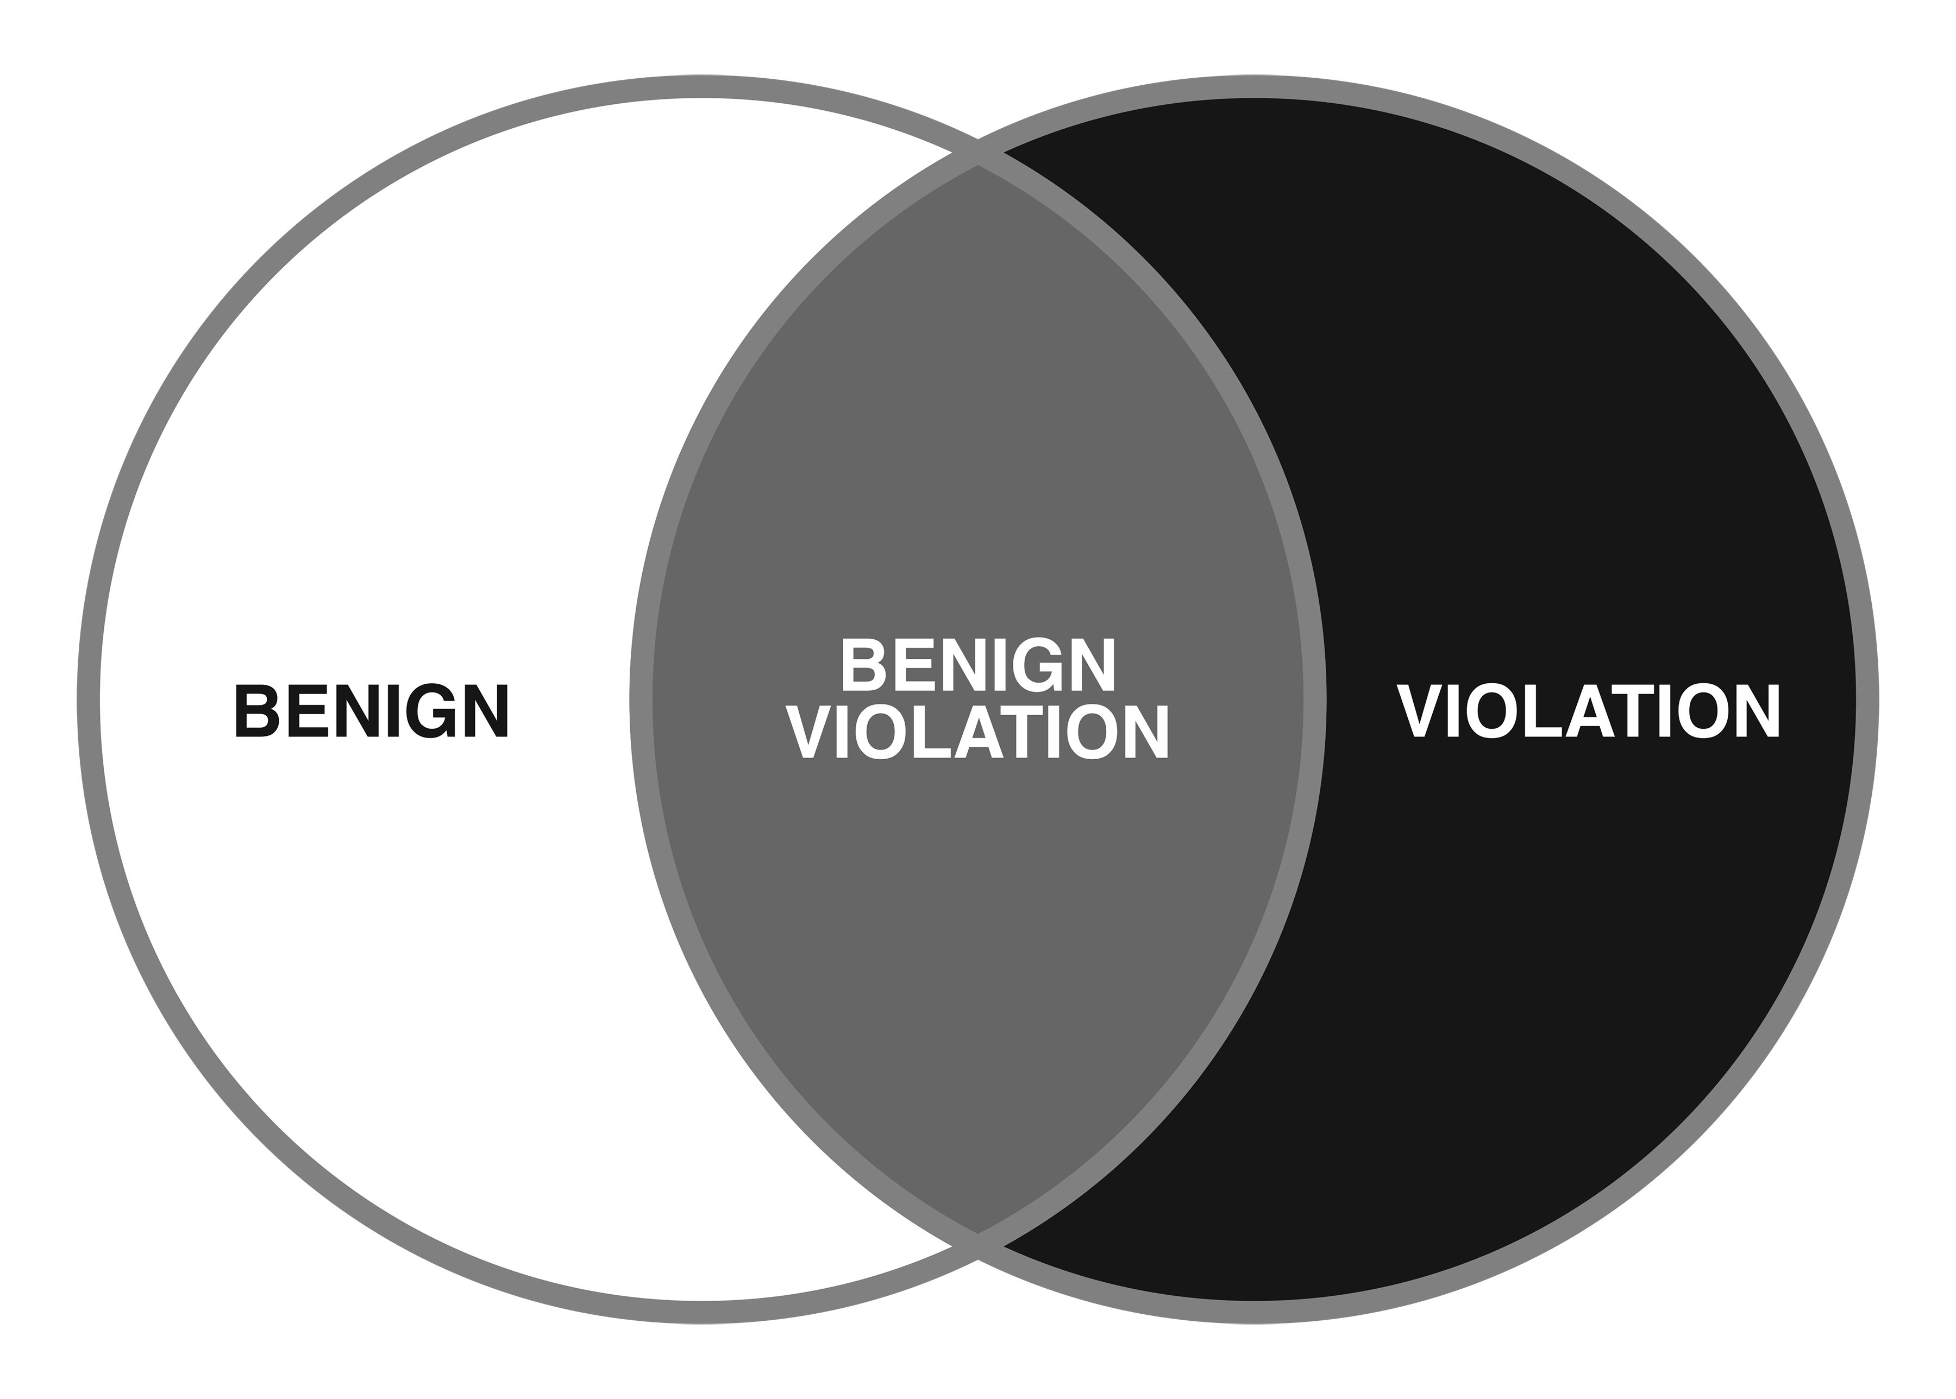 | 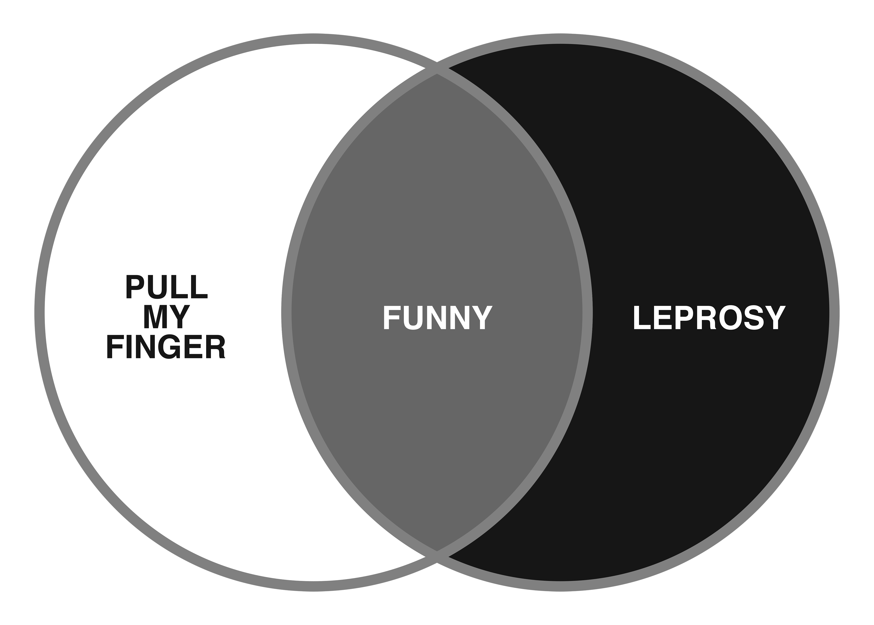
 | 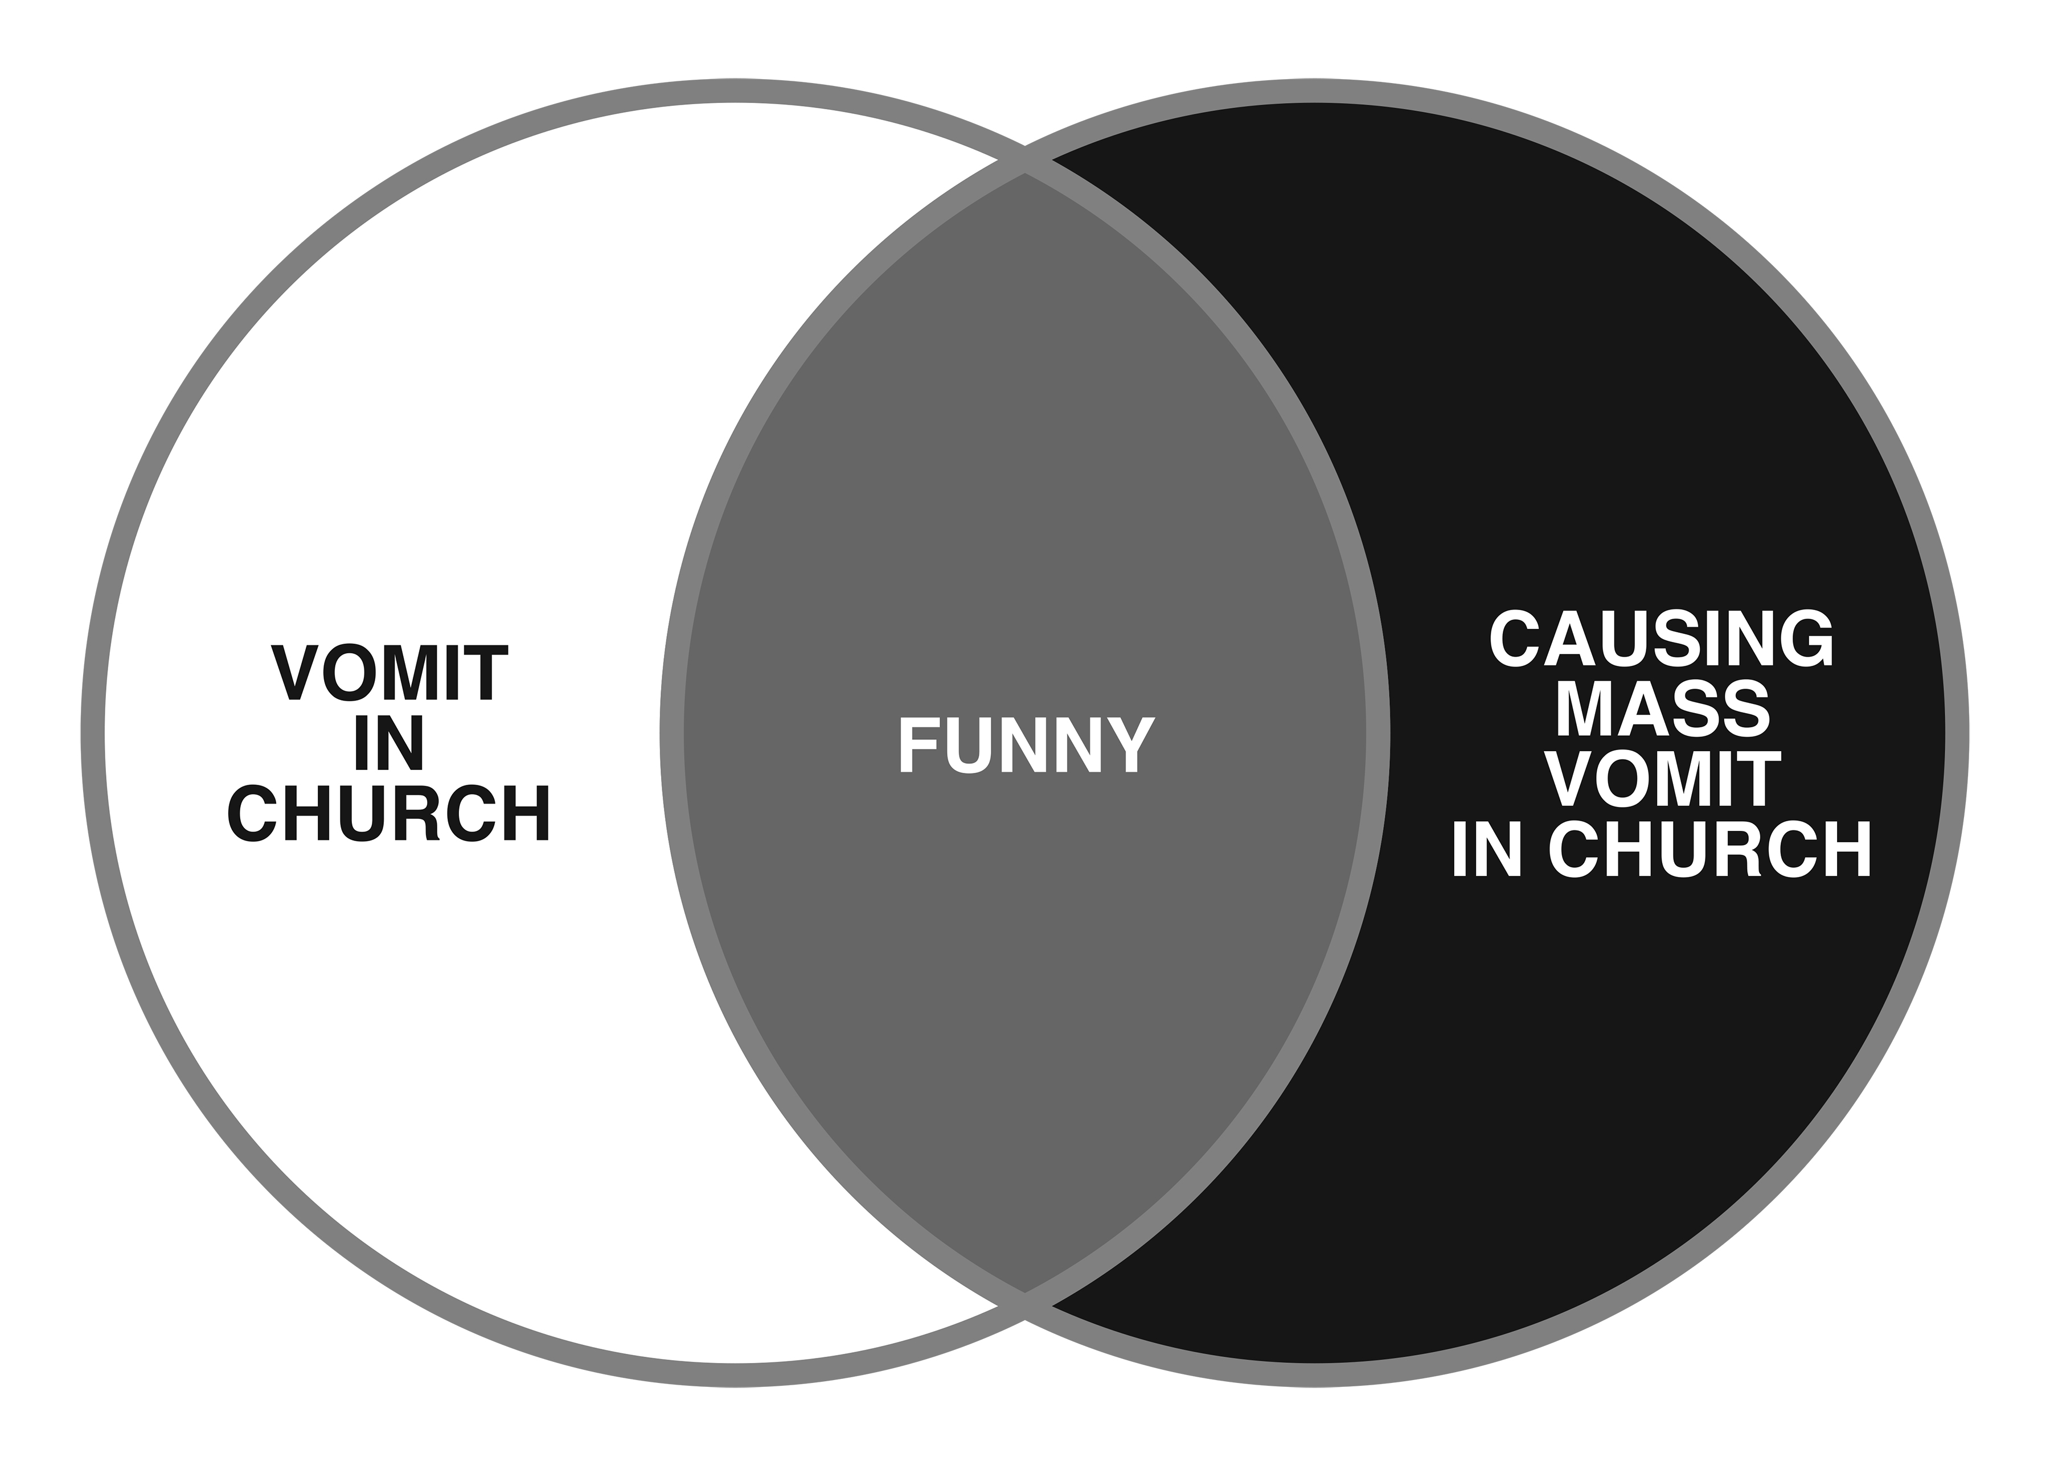

About the Authors:
Peter McGraw, a professor at the University of Colorado Boulder where he directs HuRL (the Humor Research Lab), is a leading expert in the interdisciplinary fields of emotion and behavioral economics. His work has been covered by NPR, Nightline, The Wall Street Journal, Scientific American, The New York Times and the BBC. He lives in Boulder, Colorado.

Joel Warner, an award-winning former staff writer for Westword, Denver’s alternative newsweekly, has written for Wired, The Boston Globe, Slate, Grantland, and other publications. He lives in Denver, Colorado.

About the Book:
THE HUMOR CODE: A Global Search for What Makes Things Funny
By Peter McGraw and Joel Warner
Simon & Schuster Hardcover
Publication Date: April 1, 2014
Price: $26.00
Pages: 256
ISBN: 9781451665413

Visit Simon & Schuster at www.simonandschuster.com
For author photo and jacket photo visit http://resources.simonsays.com
Praise for THE HUMOR CODE

“Funny, poignant and inspiring, Peter and Joel manage the tricky task of vivisecting comedy without losing the patient.”
— Andy Wood, co-founder and producer of The Bridgetown Comedy Festival

“If you've ever been interested in trying comedy, this book will either scare you away from it or force you to do it. I consider both options a success.”
— Mike Drucker, standup comedian and writer for Late Night with Jimmy Fallon

“Blending cutting-edge science and clever stories, The Humor Code will help you find a funnier world -- whether you are on Twitter or not.”
— Claire Diaz-Ortiz, author of Twitter for Good and innovator at Twitter, Inc.

“A harrowing tale of men obsessed with understanding a gargantuan and enigmatic beast called Funny. This book might as well be titled ‘Moby Dick Jokes.’”
— Baron Vaughn, Comedian. As seen on Comedy Central, Conan, Ferguson and his podcast "Deep S##!"

“Leave it to a reporter and a scientist to try to ruin something beautiful by dissecting it, and instead create something wonderful. The Humor Code is a tremendous book.”
— Shane Snow, technology journalist and author of Smartcuts

“I’ve always been fascinated by how humor works. I’m not willing to say that The Humor Code solves the puzzle once and for all, but it comes pretty close – and along the way it’s a hell of a ride.”
— Jimmy Carr, stand-up comedian, television host, actor, and co-author of Only Joking: What's So Funny About Making People Laugh?

“Spanning five-continents, McGraw and Warner’s quest for a unified field theory of funny may be quixotic but, like Don Q and Sancho, their misadventures are irresistible and their enthusiasm is as infectious as the laughter they chronicle. Together they manage to find the science in comedy and the comedy in science, and share it all with the reader in this playful Baedeker of humor.”
— Barnet Kellman, Emmy-Award winning director of Murphy Brown and Mad About You, professor of Cinema Arts at USC, co-director of Comedy@SCA

“Humor is like happiness — universal but subjective. What's great about The Humor Code is that it takes a scientific look at how humor differs across cultures yet vitally connecting us at the same time.”
— Jenn Lim, CEO and Chief Happiness Officer of Delivering Happiness

“Peter and Joel's globe-spanning search for what makes things funny is a wonderful page-turner that entertains as much as it informs.”
— Dan Ariely, author of The (Honest) Truth about Dishonesty and Predictably Irrational

“If you've ever wondered why we laugh at what we do, you have to read this book about the DNA of humor. The odd-couple authors take us on a journey from the halls of science to the backstage of Los Angeles comedy clubs, and they show us why people can laugh amidst tensions in Palestine or a clown brigade in the Amazon. It's part Indiana Jones, part Tina Fey, and part Crime Scene Investigation, and it will make you smarter and happier.”
— Chip Heath, author of Decisive, Switch, and Made to Stick

“The Humor Code is a fun narrative of how a serious scientific theory is born, tested, and lived.”
— Ben Huh, CEO of The Cheezburger Network

“This book tickled my hippocampus. Joel Warner and Peter McGraw gave me paradigm-altering insights into humor, but also creativity, business, happiness, and, of course, flatulence.”
— A.J. Jacobs, author of Drop Dead Healthy and The Year of Living Biblically

“The Humor Code is a rollicking tour de farce that blends academic insights and amusing anecdotes to answer some of the most serious (and frivolous) questions about humor, from what makes us laugh and why we laugh at all, to how the world’s cultures came to have completely different senses of humor.”
— Adam Alter, New York Times bestselling author of Drunk Tank Pink: And Other Unexpected Forces That Shape How We Think, Feel, and Behave; Assistant Professor of Marketing and Psychology

“If you're doing business in the global marketplace, The Humor Code is a must read. Not only did I learn what makes things humorous around the world, now I understand why nobody in Japan ever laughed at my jokes!”
— Marty St. George, Senior Vice President of Marketing, JetBlue Airways

“McGraw and Warner have done something quite remarkable and commendable. They’ve taken an intriguing question regarding the nature of humor and artfully mined answers from both the outcomes of scientific research and their own “world-wide comedy tour” experiences. I’ve never seen anything like it.”
— Robert Cialdini, bestselling author of Influence

